Moxon 2el 40Mtr Yagi @ 7.050Mhz – AO Analysis
-------------------------------------------- ANALYSIS ---------------------------------------------

Matrix Fill 0:01
Matrix Factor 0:00
Impedance 50.1 - j 4.3
SWR 1.09
Wire Losses 0.02 dB
Efficiency 99.5%

At 26.0 deg Elevation:
Forward Gain 11.06 dBi ← mounted 70 ft over ground
F/B 21.15 dB
Azimuth Beamwidth 79 deg
Radiation Peak 26 deg Elevation (11.06 dBi gain)

PLOTS:
Azimuth
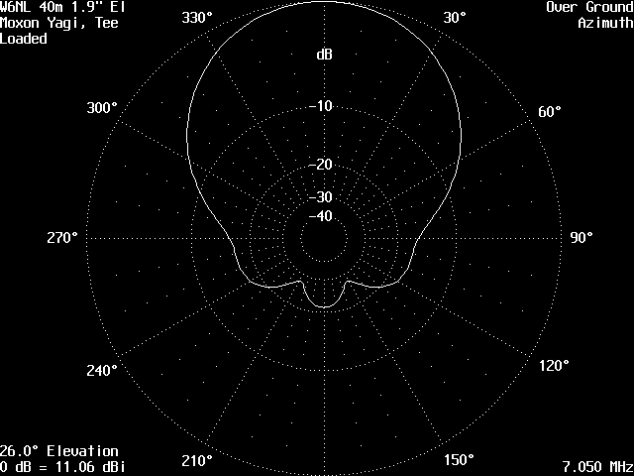

Elevation:
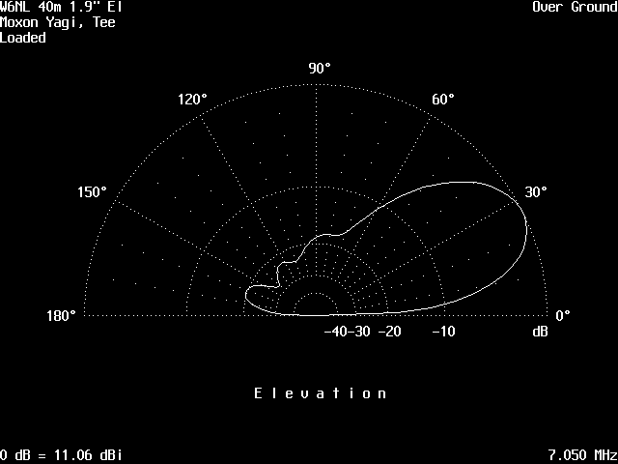
View:
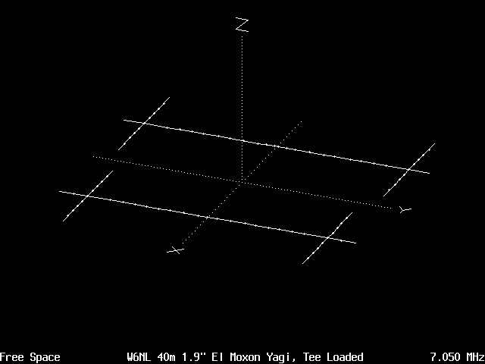
Physical representation in X, Y and Z axis for simulation.

3-D Plot :
